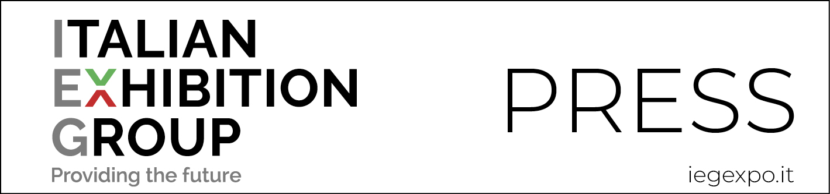

press release
(English translation)

IEG: A COMPLETELY SAFE RESTART
Business and health at the core of Rimini and Vicenza’s total trade show activity restart.
Green Pass to enter and a Covid-testing service.
Ten shows scheduled in the month of September
Rimini (Italy), 1st September 2021 – At the show in total safety. This is the objective that IEG – Italian Exhibition Group – is following during a season of recovery to protect the health and business of its customers.
Entrance to the Rimini and Vicenza shows managed directly by IEG will therefore be allowed on presentation of a Green Pass (which certifies either recovery from Covid or vaccination). Body temperatures will also be checked and face masks must be worn. Those not in possession of a Green Pass can enter by providing a negative test taken within the previous 48 hours.
Those from non-EU areas must provide a vaccination document in the English language showing the type of vaccine received, which must be EMA approved.
To offer an additional service, IEG will set up a rapid antigen testing point outside the Expo Centre for those who, for whatever reason, cannot provide a Green Pass or who need a test result to return to their country of origin. The test point will be open every day of the show. The day prior to show opening, the test point will be available for exhibitors only. The service, which can be booked on line, will cost 15 Euros.
The circle closes with IEG’s adoption of the Safe Business protocol and accreditation obtained from GBAC STAR™ due to compliance with the international standards of cleanliness, disinfection and risk prevention. Further guarantees for Covid-free halls and a business-focused visitation.
Italian Exhibition Group’s other shows scheduled in the month of September at the Rimini Expo Centre are: Macfrut and FierAvicola from 7th to 9th September, Expodental from 9th to 11th September, Enada and Rimini Amusement Show from 21st to 23rd September, RiminiWellness from 24th to 26th September and IBE International Bus Expo on 29th and 30th September (which will be held at the Misano World Circuit Marco Simoncelli).
Instead, those on the Vicenza calendar are Vicenzaoro September, T.Gold from 10th to 14th September, with VO Vintage from 11th to 13th, while Rome Expo Centre will be staging Abilmente Roma from 23rd to 26th September.

PRESS CONTACT ITALIAN EXHIBITION GROUP
Head of media relation & corporate communication: Elisabetta Vitali; press office manager: Marco Forcellini; international press office coordinator: Silvia Giorgi; media@iegexpo.it

FOCUS ON ITALIAN EXHIBITION GROUP
Italian Exhibition Group (IEG), listed on the MTA (screen-based stock exchange) organised and managed by Borsa Italiana S.p.A., has built up over the years, through its Rimini and Vicenza venues, a position of domestic leadership in the organisation of trade fairs and conferences, and has developed its foreign activities - also through joint ventures with global or local organisers, in the United States, United Arab Emirates, China, Mexico, India - which have positioned it among the leading European operators in the sector.

This press release contains forecast elements and estimates that reflect the management’s current opinions (“forward-looking statements”), particularly regarding future management performance, realization of investments, cash flow trends and the evolution of the financial structure. For their very nature, forward-looking statements have a component of risk and uncertainty, as they depend on the occurrence of future events. The effective results may differ (even significantly) from those announced, due to numerous factors, including, only by way of example: food service market and tourist flow trends in Italy, gold and jewellery market trends, green economy market trends; the evolution of raw material prices; general macroeconomic conditions; geopolitical factors and evolutions in the legislative framework. Moreover, the information contained in this release, does not claim to be complete, and has not been verified by independent third parties. Forecasts, estimates and objectives contained herein are based on the information available to the Company as at the date of this release.

